ADDITONAL MATERIAL FOR A FAMILY HISTORY
[It was clear from my mother's notes that her history was only in a draft form and that she intended to add various other sections and more details. I have gathered together some of her various notes and added them in here under the heading additional material, so her research and ideas will not go to waste. Perhaps in the future another descendant will undertake their own study and add more to this history.
Where notes were handwritten I have typed them up and I have only added my own comments where I think they might be of help - these are within square brackets and in italics – otherwise I have left everything as I found it. CJD August 2025]

CHRISTOPHER AIREY – an outline

1843 22 Feb: born at Airey House, Hardendale
Census 1851 at Hardendale (age 7)
Census 1861 at Hardendale (17)
Census 1871 at Castlehow Scar (27, unmarried,)
Census 1881 at Castlehow Scar (37, unmarried)
1890, 4 Dec; father dies, aged 90
Census 1891 Head of family at Castle Howe Scar (47, unmarried)
Marries his housekeeper, Elizabeth Smith July-Sept?
1892 daughter, Alice born
1894 son, Christopher born 18 Sept
1895 move to Brackenber, Shap
1897 Elizabeth (Lizzie) born
1899 Henry born
1919 22 Feb: dies of flu, aged 75
1949 3 Feb; widow Elizabeth dies, aged 85

Also 1851 Castlehow Scar, 154 acres, 4 labourers, Crosby,
Henry Riggs 35
Wife 34
3 children under 6
1 female house servant 20
1 male farm servant 15

VISITING AND BEING VISITED

2 May 1904 Sarah A. Ebdell, Great Asby, writes to Miss A. Airey that- she has the "offer of a drive to Shap on the 4th May, all being well, I think I shall avail myself of the opportunity of spending the day with you," (Emily thinks this might be for Shap Fair which was on May 4th)
Feb 1906 Joe Smith (brother) writes from in London NW
1908 (To ES) Harry (brother) and Belle Smith arriving tomorrow!
"The doctor has ordered me away for a change of air"
1910 EA writes from Old Swan, 45 Leinster Road, Liverpool - the police station where a brother was based.
25 May1910 Cousin Aggie from Annan (probably working in a big house):
"Having a holiday 4 June, Convenient to come then or on 10th?"
30 May1910 Dear Alice; leaving Annan ½. past 11 train; "I do not know what
time I shall, get away from Carlisle."
8 Aug 1910 Belle from York is coming to stay
1913 Alice is at Morecambe
Ethel Wilson, daughter of Annie (nee Irving) staying with ES (Aug 3)
ES is expected to visit Ingleton (EIiz Noble's)
ES at Langwathby (with policeman brother)
1914 ES sends PPC from Penrith
1915 Joseph Smith's wife (sister-in-law) staying at Brackenber
1924 ES staying at York, reporting day out at Scarborough
5 Aug 1924 ES tells Alice she can't come till after Tuesday! Visitors are coming,
1926 ES to Emily; staying at Mountain View, Kendal
ES: Emily and Alice have arrived safely from Reagill on Thursday night, "Don't come for them till Sunday"
1929 ES: H, at Kendal expecting Harry from York
1933 ES to Alice; "feeling a lot better" at Morecambe

With the albums was a handwritten list of times sent to Elizabeth on 23 Sep/t 1924; it looks like the timetable for a carrier, essential for this great dispatcher of messages and goods!

Shap 1:45
Thrimby 2:10
Hackthorpe 2:25
Clifton 2:42
Eamont 2:55
Yanwath 3:05
Tirril 3:15
Pooley Bridge 3:23

[Included in Mollies notes were also four pages of hand written notes from her brother Bill Airey. She must have sent him a draft version of the Family History to get his views and suggestions, probably in 1995. Bill provides very thoughtful comments and additional details, particularly regarding divisions within the family and, of course, being a farmer, the benefits of mechanisation and the varying productivity of land.

Regarding the divisions within the family, I believe that those who were directly concerned are now long dead but as a child, when visiting either my Great Auntie Alice or Great Auntie Lizzie, I remember being told never to mention the one to the other.

Divisions within families can run deep and last a long time; often the reasons arose from the division of goods and property in wills but they also came about because someone had been forced to stay at home to care for an elderly parent when other siblings had left home- this latter was the cause of trouble on the Dixon side of the family.]

Comments on the draft document by Bill Airey.

There are two sensitive issues that should be handled with care.

1. Regill Town Head.

Uncle Richard’s original will left the farm to be sold and the proceeds divided between Alice and Lizzie, or valued and Alice to pay Lizzie half. Alice found out of maybe was told about it by Uncle Richard, and having been told, Alice could not resist telling others, the news eventually getting back to Uncle. This he regarded as a gross breach of trust, so he did his own valuation (£1000), left Town Head to Alice, requiring her to pay Lizzie £500. This indiscretion cost Alice £150 (not easily found at that time).

[There is a note here from Mollie to “get grt-grt-uncle Richard’s will (the excise officer)”]

2. Richard’s gold watches.

He left a watch to all his nephews. I do not know whether all were gold or some silver. There was however some difference in value either actual or sentimental or both. Father got Richard’s personal gold watch, presumed to be most valuable on both counts. Auntie Madge and Agnes always thought that Uncle Henry should have had that one. This has always been a sore point and still surfaces from time to time.

[There is a note here from Mollie, “because Father would get his Father’s presumably and so Henry should get Richard’s best.”]

Shap Abbey.

This should be at the beginning with a reference to Thomas, William, Edward and Henry Ayraye, as the eventual objective would be to trace back to one of them if possible (Henry?). Were these 4 brothers, cousins, father, sons, grandsons, uncles, nephews or what?

Maps.

There is hardly ever a best place for this kind of map as one needs constantly to refer to them while reading. Try reading a book with a large map folded up at the front or the back.

Quakers.

What were the consequences of their being Quakers? Fines and imprisonment would have adverse economic effects, but how long did recovery take?
There may have been educational advantage, but later committed membership to C of E could have similar gains.

Long Generation Gap.

Was this entirely for economic reasons? We note good education followed by taking the Scar which would need capital for the extra livestock etc. Was money borrowed to finance this expansion?
How was late marriage influence by housing shortage? There were apparently no cottages convenient to the Scar. It would be interesting to compare population figures with the availability.
Richard’s interest in women seems to have been confined to dancing with them. Maybe Grandfather was also lukewarm.

C&R Airey Partnership 1890-90

When this was dissolved (assuming a sound financial position) Richard would have significant capital which would allow him to eventually buy Town Head, The Nab and land in amongst Brackenbur land which Father inherited (20 acres or so I believe), Henry getting The Nab. Father got no buildings but probably the best land.

Land at Brackenbur.

I find it very difficult to identify all the land that belonged to the Aireys. Some land would be lost to Colville Quarry and the associated rail link. I remember dad coming back from a visit to Shap and telling that one field that he had ploughed regularly was now covered by 50-60feet of miscellaneous material and lost for ever.

There are a number of interesting points about the Brackenbur land:
The Carlisle and Lancaster railway seriously affected the earliest enclosures. How were the owners compensated for the loss of land and inconvenience? Some apparently worked for the rail company, hiring out horses and carts and maybe men. Would there be sufficient financial gain to enable them to enclose more land?

Apparently Grandfather took stints on Hardendal Common. The commoners at Hardendale did not have great numbers of stock and if persistently undergrazed all grassland deteriorates so letting stints to outsiders not only produced income but maintained the quality of grazing for themselves. It is possible the Bracken bur land and land rented at Hardendale and stints taken on the Common would give Brackenbur a potential higher than at first realised. The Scar had mainly a thin soil over limestone and suffered badly in a dry time. What was the climate 1860-90?

It is impossible to locate some fields. Were is the L field? Some walls were removed to improve the layout. One year Uncle Richard said he would hoe the turnips if Father and Uncle Henry or a hired lad (Jack Newton?) moved the stones by horse sled to the new site. Then when the rest made the hay Richard built the new wall.

It should be remembered that this was the age of the two horse mowing machine (Bamford or Walter A Wood) and the Jarmain patent saw tooth swath turner. These machines not only made the long scythe and handrakes largely redundant except for corners etc. but allowed Richard the time to build the wall.

I never saw the patent swath turner at Shap but there is one at the Beamish Museum. The saw tooth machine was superseded by a Blackstone design with L shaped tines that also loosened the swath instead of just rolling it over.

Our main problem in understanding Brackenbur is that we never lived at Shap when old enough to understand or visited it very often.

[Bill concludes with the following, very typically as a farmer, mentioning the weather]

“This is what I can offer at the moment. I hope some of it is of value. We are all well here and hope you are too. The weather is now sunny and warm but it is nearly May, almost half of 1995 gone. Time does seem to fly.”

[Of course, he was not to know that the following spring, 1996 would see his sister's untimely death.]

[I have included here some pictures of the machinery Bill describes in his comments. While not in my mother's original scheme, they give an idea of the changing pace of technology as farmers moved from scythes to horse drawn mowing machines, a change that is apparent in the Family History]

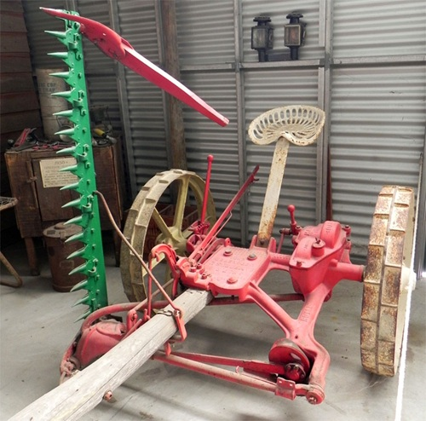

The Bamford Two Horse Mowing Machine.

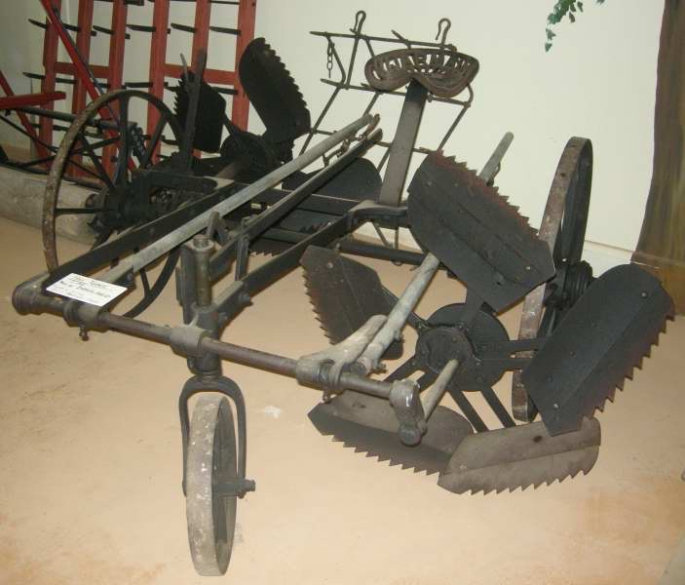
The Jarmain Patent Sawtooth Swath Turner.
Note the shafts have been folded back onto the machine.

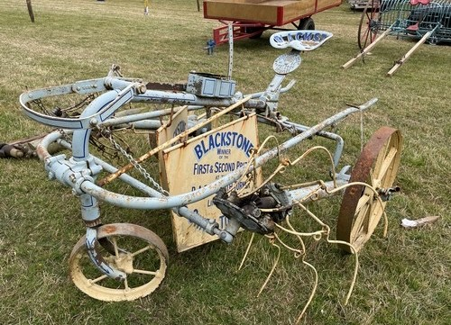
The improved design of the Blackstone Swath Turner.
The L shaped tines loosened the swath. The shafts are again folded back.

[The following are from Notes written by Mollie's husband, John Dixon, about Mollie's Aunt Alice who was seen as “the family historian”. It provides a little more detail about the life and times of the Aireys.]

John Dixon, memories of Mollie's Aunt Alice

“Her father, Christopher Airey II, was born in the 1840s, her grandfather, Christopher Airey I, in the 1800s – he could remember Napoleon, she said. I later found that for Westmorland yeomen this spacing was quite normal, for social reasons.
Though she was too young to remember her granddad – she was born in the 1890s – she told us how her father had gone along with her grandfather to the table of Lord Lonsdale’s steward, when they asked to rent Castle Howe Scar, a bigger farm than their hereditary holding in Hardendale. The steward had just two questions for Mr Airey, was he a member of the church of England, and did he vote Conservative? This we discovered was how the Lowther family had secured 8 or 9 seats in the Commons, when they became members of the ‘King’s Friends’ to George III. (Wordsworth’s father was one of his agents, for Cockermouth, we learned.)

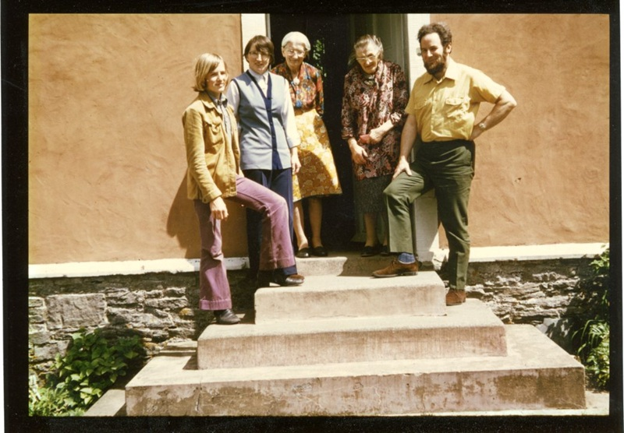
“Family memories (and fables): you commit to memory the moments you’re proud of, or your family felt rueful about. Thus, her grandfather’s brother, Richard, after an education at local grammar school, had secured a post in the Inland Revenue and ended up in the Highlands as a customs inspector – for the whisky industry and maybe more. When he died, Chris II had to serve as executor and go up to pay debts etc. He ended up, said Alice, with what was left, a white pony and trap he came home in – plus an instrument for testing the strength of the alcohol. Apparently Richard left a good local reputation – for whatever reason.”

A picture taken at one of the cottages at Isel Grange, Chris and Mary Airey's last home.

On the steps from the left, Rob (Mollie's younger son), Mollie, her mother Mary, her Aunt Alice who features so much in the Family History and Mollie's husband John Dixon.

Bill's son Alan described his Great Aunt Alice as “a great character who took great delight in speaking local dialect and telling stories about the family and Penrith & District”.

[Various maps were included in with Mollie's notes including attempts to identify the land that went with Brackenbur but as Bill says, it is probably not possible now to determine exactly which fields went with the farm. Although Mollie intended to include maps in the Family History, Its not definite which one or ones she intended to use, nor where to fit them in the History, so I have used my best judgement and included the additional maps here rather than just exclude them.]



