FAMILY HISTORY

the ancestors and the background
of

AIREY IRVING
Christopher Mary
1894-1972 1895-1978
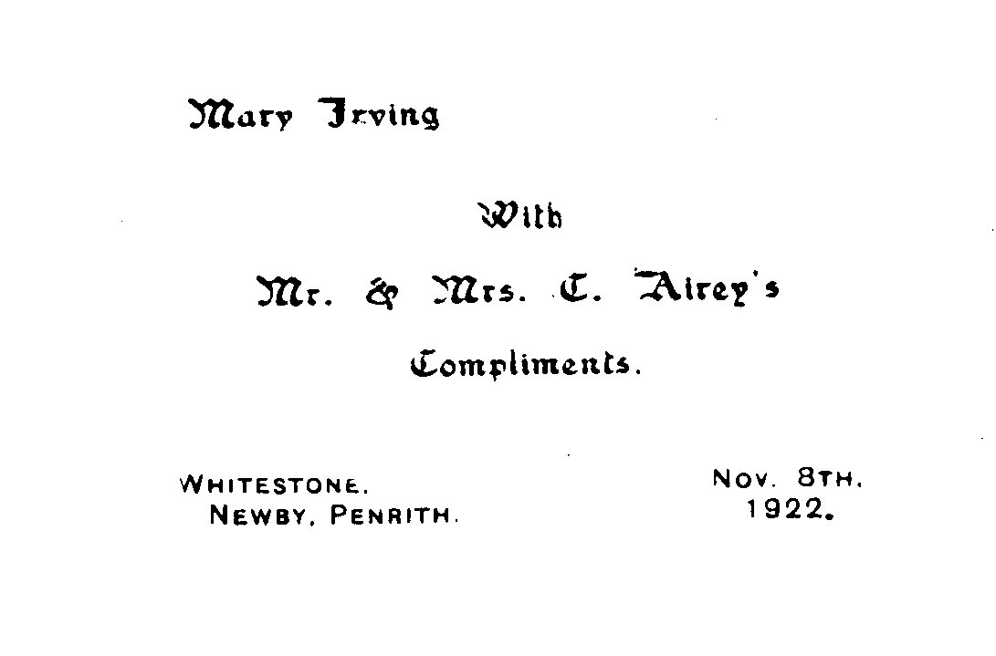
from the point of view of their children

Mary Elizabeth (Mollie) Christopher William (Bill) Barbara
14 Sept 1924 3 Oct 1925 8 Jan 1929
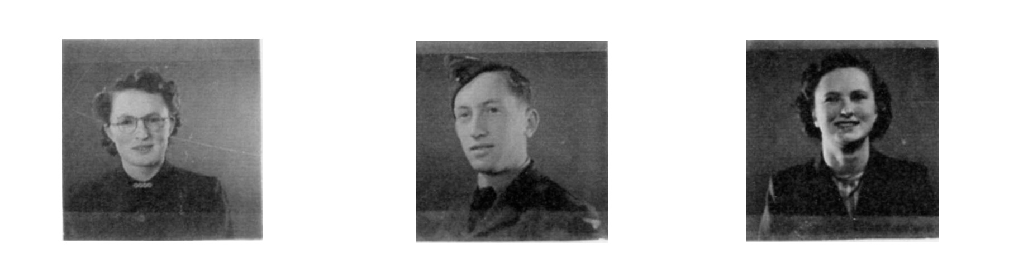
hoping it will also be enjoyed by our cousins, Emily Crosbie;
Joe, Frank & John Armstrong; and Agnes & Richard Airey

BEGINNING A FAMILY HISTORY

John and I started to collect fragments of "family history" in the early 1970s, most of them written down as we talked with Mary (my mother) and Alice (my father's older sister) on our regular summer visits to Isel. As we heard these two talking away well into the night, we realised how lively and interesting it would be to take them round some of the farms where they'd grown up as girls and where relations and friends had lived. Listening to their recollections at the various places}and looking with them at photos in the family album, inspired us to start our own collection of photographs and slides of the farmhouses as they are today and their surrounding countryside,
Thus, our "tours" began in 1975 with Brougham, Clifton and Shap. We have a particular memory of Mary talking to the couple living on Wetheriggs (in Brougham Parish) where her father had farmed - she had known the parents of both! For Alice it was a particular pleasure to revisit the west side of Shap, find a relative at Tailbert and point out to us where Rosgill and Bampton lay. When we were invited into Abbott Lodge (Clifton) - where my maternal grandmother Annie Elizabeth Graham was brought up - we were astonished to find a relative of Sarah Harrison who taught me, Bill and Barbara at Sunderland School. Such connections were the start of our interest in networks and continuity.
However, changes are significant too. John's voluntary early retirement in 1981, as part of the plan to save his college in Yorkshire, led to a decision to move to London, where we would be able to continue some academic work. But we were also able to build up our family trees through records readily to hand in a capital city: the Genealogical Index (of Marriages and Births) and the Censuses for the 19th Century in the Public Record Office in Chancery Lane; the records of Births, Marriages and Deaths in St, Catherine's House; the printed Parish Registers and Directories in the British Library.
In 1991 our "tours" expanded, as my brother Bill had retired from farming and could join us. Visits to Whitehaven, for its museum and Moon's bookshop, added to our awareness of the industrial development of West Cumberland and the enormous power of the Lowthers, as politicians, developers and landlords. We looked at more of the farms of my mother's forebears - the Kitchens, Grahams, Robinsons and Irvings - on the red sandstone of the Eden valley; and compared my father's Airey, Dodd and Farrer ancestors on the limestone of Shap, Hardendale and Orton. And in the Carlisle Record Office we could now systematically look for 18th and 19th Century Wills which gave us a notion of a person's financial standing and provision for family.
By this time I had recovered with certainty the names of two thirds of my gt-gt-gt-grandparents and others as strong possibilities. This is quite an achievement for families which don't figure in the conventional history books or social studies. But, once you're researching earlier than 1750, you can spend hours poring over the Genealogical Index or the Parish Registers, only to have to admit that it's impossible to sort out all the families, especially if the ancestor is a John Robinson or a John Dodd. When there's a John, Thomas and Henry Dodd for three generations and they all keep much the same small group of first names for their children, it seems time to get control of this addiction, and take stock of what you're achieving.
I eventually realised, following John's way of looking at his ancestors, that what's more interesting and valuable is to try to flesh out the names and visualise them as real people, on their isolated farms or in a village, managing their lives with very varying resources and a fluctuating market for what they could produce. So, how did our ancestors cope? Can we get anywhere near what their lives were like? Many aspects and questions came into the back of my mind as I searched.
How productive or hard to work was the land these people from the Eighteenth and Nineteenth centuries made their living on? How did our ancestors on the red sandstone soil of Clifton compare with those on the limestone ground of Shap and Hardendale or the wetter land of Sleagill or the Birkbeck Fells? And who or what persuaded three ancestors on our mother's side to move out of Cumberland into Clifton - great-great-great grandfather Robert Irving who moved from Seaton via Dacre; and two great-great-grandfathers, Thomas Kitchen from Watermillock, and Robert Graham from Brigham via Hesket,
How healthy were they able to be, with limited diets and faced by diseases and ailments which couldn't be treated before the days of penicillin and operating theatres? What happened to a family hit by the early death of a father or mother? The brother of my great-great-grandmother Ann Farrer-Dodd lost his wife and died himself when the eight children were all under age, from 18 down to 4. A cousin, Elizabeth Dodd~Airey took one of them as her first servant. Great-great grandmother Isabel Hesket-Graham's first servant was the daughter of a sister who had died in Liverpool.
These examples - and there will be many others - show the importance of kin and a network of support. My father's mother, Elizabeth Smith-Airey, kept in touch - through visits, letters and parcels - with a big family of brothers and sisters, their families and her own former maids Thomas Kitchen had his elderly parents with him at Brekinber Hill, Clifton-James in his 80s and Ann in her 60s.
It wasn't only the nature of their land or the accident of illness or early death that they had to contend with. The prosperity of the farms and villages depended on the demands of the country - for more grain during the Napoleonic Wars; for less in the aftermath. And in 1846 the decision was taken by Parliament to buy food in the cheapest world market and to live by exporting manufactured goods, especially cotton.
Besides this reduced demand for produce, new agricultural machinery came in during the 1850s, mowing machines, binders, improved ploughs, mechanical threshers - needing fewer labourers. Through the Censuses we can see our own ancestors' families leaving the land for the new jobs on the railways and in the granite and cement works, or moving into the expanding social jobs such as teaching or, as in the case of all six Smith brothers, the police force.
On the one hand, our ancestors-are the microcosm, the "little world" which gets on with its day to day life. They contribute to social history as practical examples of what was going on, as individuals who lived and had a tiny but active part in the bigger world. On the other hand, their individual lives were being controlled by the aims, decisions and actions of the powerful local magnates, the country and the national government. To survive, they would have to accommodate to outside events and inventions which were bringing about change and which in the end would shift England and Wales from a mainly agricultural to an industrial economy.
As I write up what I've discovered about their day to day lives, I'll put in some account of this wider background where it seems to fit. I'll make a start with my four grandparents, where I have the most information either through knowing them myself or from talking with relatives who knew them.

GRANDPARENTS
Christopher Airey
1843-1919
Elizabeth Smith
1863-1949
married 1891
at Shap

HARDENDALE
CASTLEHOW SCAR

MILBURN
SLEAGILL

BRACKENBUR
Shap

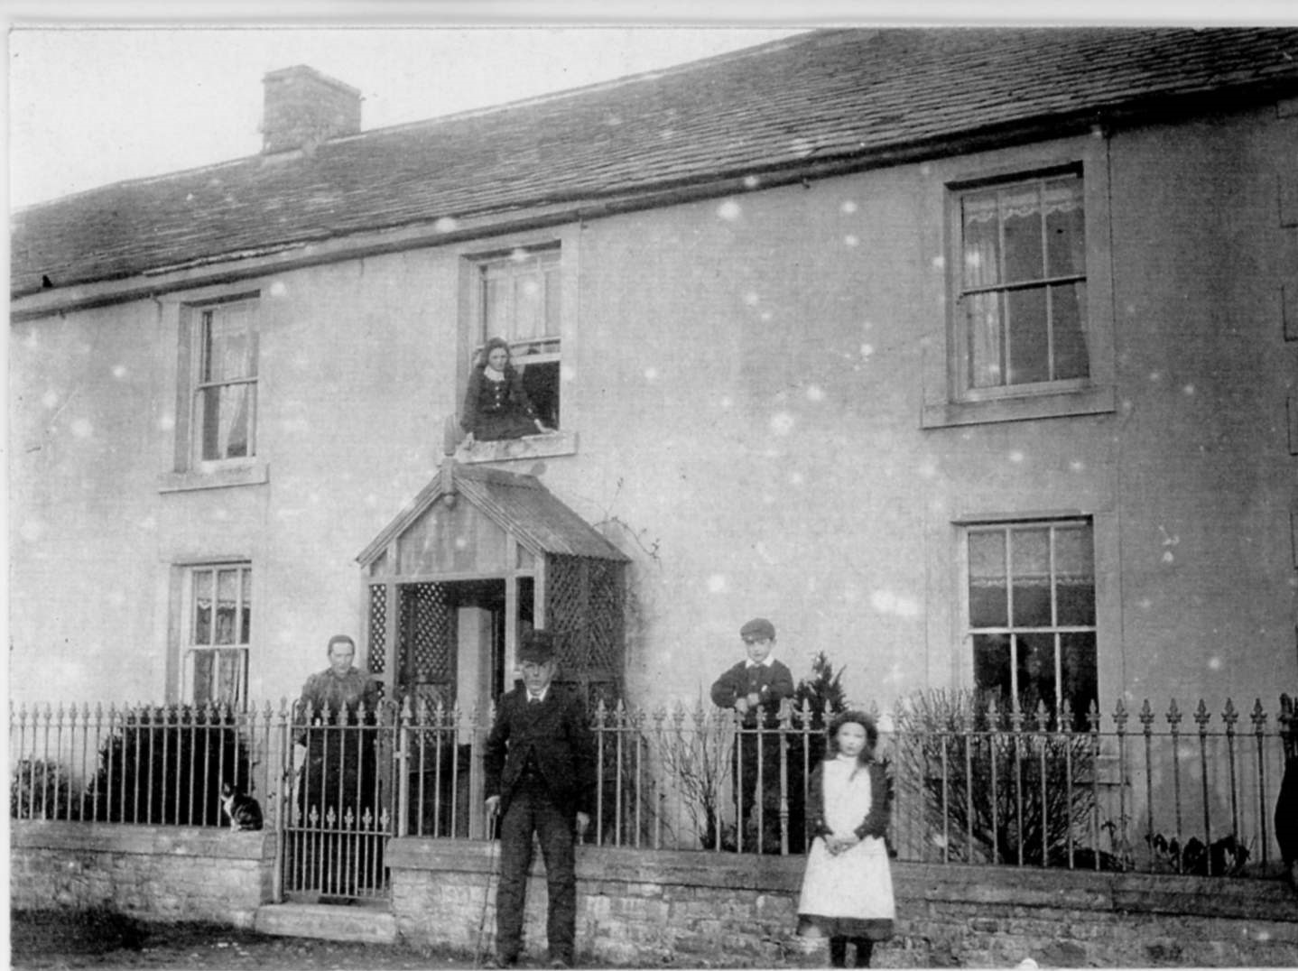
OUR FOUR GRANDPARENTS

The two pairs had very different backgrounds. Our father's father, Christopher Airey, typifies the farmer working on the higher and more exposed limestone ground in Westmorland. He's an example too of the problems of an eldest son who couldn't marry until his father died. When he did marry, at 48, he moved from a rented farm of 193 acres to the old family holding in Shap, increasing it from 11 acres, but only to 60. For himself, there were immediate advantages; he was able to take the breaks that now seemed necessary for his health; and his buying of land and his support for the Church placed him in a higher social circle with the roles of Churchwarden and member of the Board of Guardians,
Elizabeth Smith, our grandmother on this side, was the eldest of eleven children. At seventeen she was helping to look after the six under twelve who were still at home, on 11 acres in Shap, with no servant. Marrying Christopher Airey may have seemed a better prospect, despite the twenty years difference in age. She too was a devout supporter of the Church, accepted in the vicarage circle at Shap: and she held together a large network of relatives,
However, in the end, the late marriage and the small farm inevitably disadvantaged the children. Grandfather's chief helper was his bachelor brother, Richard, who held to the old ways of farming. Who could introduce the young Airey boys to the new machinery? There was no way this unmodernised farm could provide for two surviving members of the older generation, set up two sons in farming and give two daughters a dowry.
Our mother's parents, too, both had a serious disadvantage at the start of their lives. Grandfather William Robinson Irving's mother died just over a year after he was born. His father was a general labourer in 1881, though connected with Brougham Hall through his work as gamekeeper. But the prosperous Robinson kin no doubt spoke for young Bill when he applied in the 1890s to rent Weatheriggs, the farm his late Mother's father had held for around forty years.
Grandmother Annie Elizabeth Graham's father died at only 23, after an accident with a gun, six months before she was born, Her mother was helped by one of her Kitchen brothers to continue farming at Abbott Lodge, the biggest farm in Clifton, on the rich red sandstone of the Eden Valley. Annie was used to a big and comfortable household of ten people: five members of the family, one maid and four farm workers living in,
This pair had more resources behind them and they were able to marry in 1894 at 26 and 21 (compared with 48 and 27 for the Aireys). By 1916 they envisaged a marriage into a neighbouring farming family for our Mother (though the war ended that hope) and they had sons able to do a man's work while they themselves were still in their forties.
They were well equipped to move to Cumberland in 1926 and settle on one of the best farms in Isel parish, bringing their big Clydesdale horses with them. Besides, both sons were interested in machinery and could cope with technical innovations. From the early twenties there was a car, as well as their motorbikes, in the machine-shed.

SHAP ABBEY

The only remains - the ruined west tower of its 15th century church.

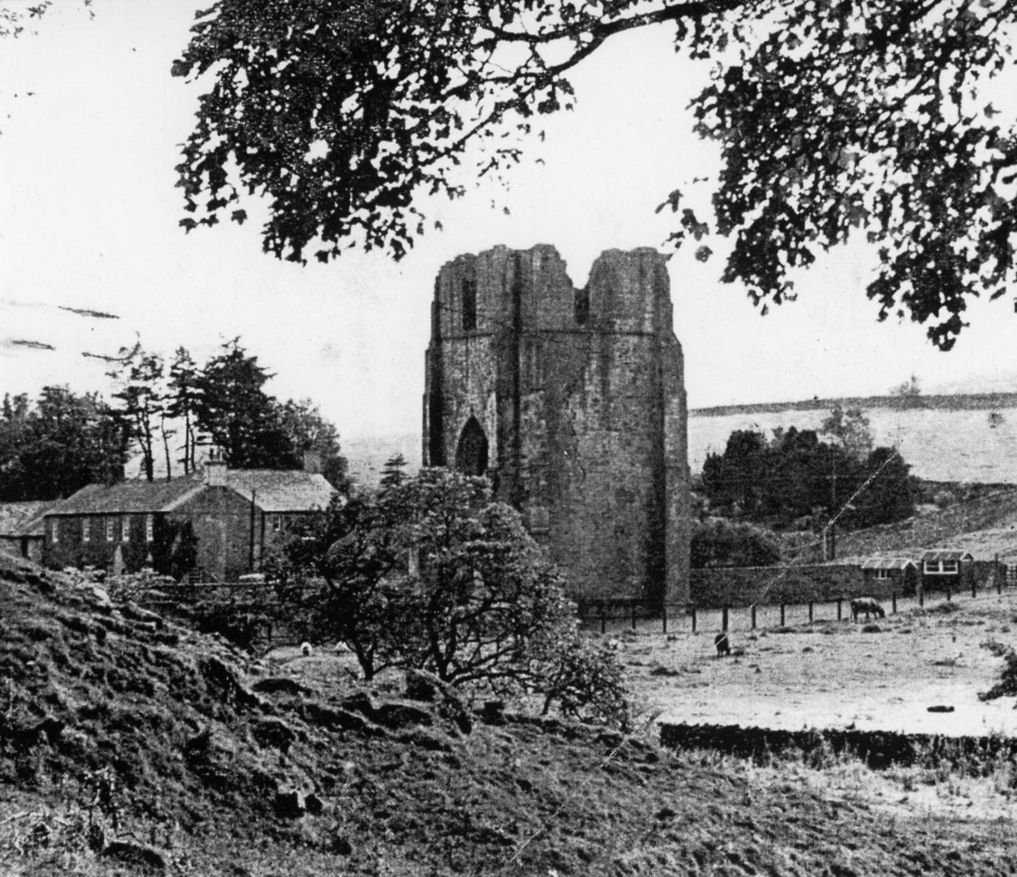

A once famous monastery, in the Lowther valley a mile west of Shap, occupied by monks called Premonstratensian, from Premontré, where this Order was first established by Archbishop St. Norbert around 1120, They became known as White Canons, from their white cassocks, cloaks and caps.
Thomas, son of Gospatric, Earl of Northumberland, brought a group to Westmorland, first to Preston Patrick and then on to Shap. He gave them pasture for 60 cows, 20 mares, 500 sheep and five yoke of oxen; and their lands were later extended by local benefactors, the Veteriponts and Lowthers among them.
When Henry VIII's commissioners came round, there were twenty monks with an annual income of £154, 7 shillings and 7 and 1/2pence They escaped this first round of destruction, but were disbanded four years later in 1539. The Abbey and its lands were granted to Sir Thomas Wharton of Wharton on easy terms -a twentieth of a knight's fee and £4.11 per year to the King's Exchequer.
When the Abbey went, the destitute, the handicapped, the sick and the vagrants lost the place which gave them shelter and food; they became the responsibility of the. Parishes.

BRACKENBER, Shap: AN ANCESTRAL FAMILY HOLDING?

Our grandfather CHRISTOPHER AIREY, born in 1843, is very likely to come from a Shap family going back to one of the four Aireys who were tenants of Shap Abbey at the time of the dissolution of the monasteries. We find Thomas, William, Edward and Henry Ayraye listed as having tenure of land which was granted by the Crown at this time to Sir Thomas Wharton. So far, however, we can't trace the connections back with certainty further than the Christopher born in 1729.
Bill, Barbara and I in the 1930s and 1940s grew up on the Glebe Farm and Westray (in Isel parish, near Cockermouth), and we regularly heard about the Shap Aireys going back four centuries or more and about Brackenber as the family farm in Shap. However, we now know that our grandfather was born not at Brackenber but at "Airey House", Hardendale. What's more, his father was born there in 1800. Why had the Aireys been away from Brackenber and Shap village for most of the nineteenth century, and possibly half the eighteenth? (We'll have a look at the possible answers later.)

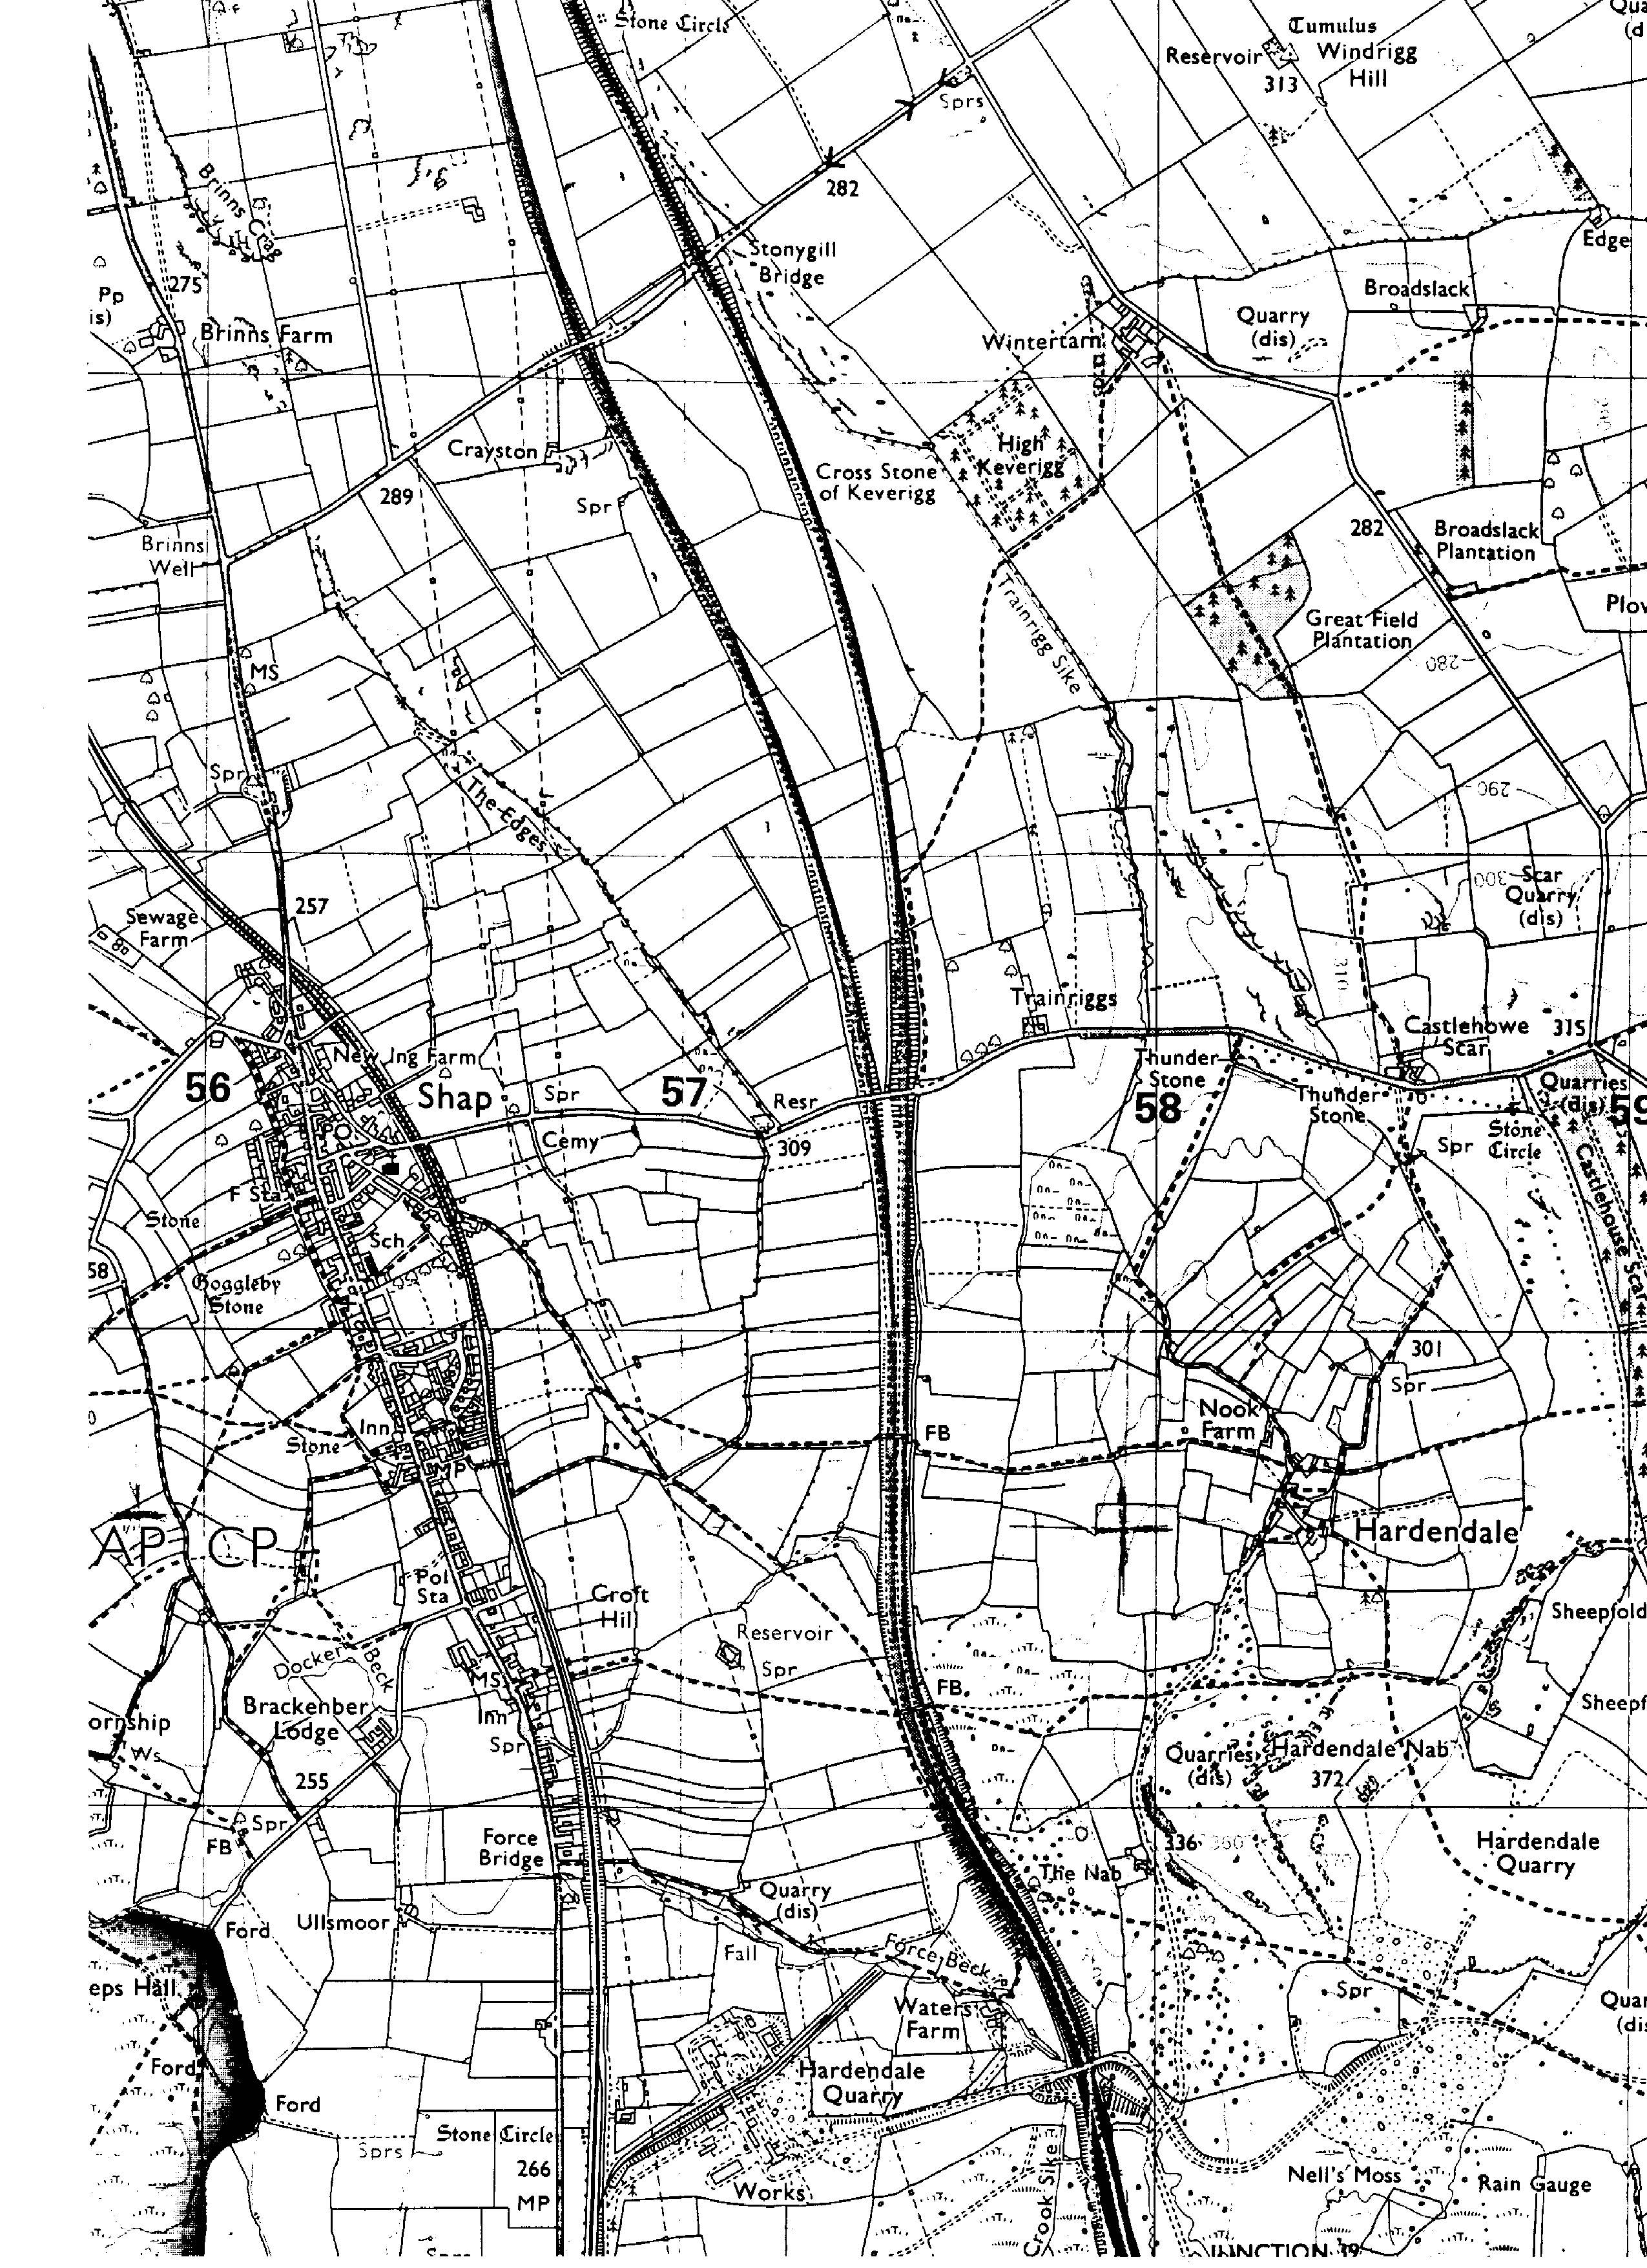

ECONOMIC EFTECTS OF LONG GENERATIONS

My father was born in 1894, just before the move to Brackenber. Let's put that date alongside the dates of birth of his direct ancestors:
Chris 1729 - Henry 1756 - Chris 1800 - Chris 1843 - Chris 1894
We find three generations well over average length - with intervals of 44, 43 and 51 years between births. Is this is a sign, as it was on the smallholdings of Ireland, of shortage of resources causing a son to postpone his marriage, often till his father had died? Or is it simply the pattern of this particular, and perhaps unambitious, family? (I should say, though, that Henry must have married in his mid-thirties: his problem was that his first children were five daughters, and a boy who didn't survive.)
Whatever the cause, there's a serious disadvantage in this kind of situation. When, for example, our great-grandfather (the 1800 Christopher) was 50 the two sons who would eventually be able to help him were only 7 and 5. When our grandfather (the 1843 Christopher) was 50 he had only a one year old daughter. When he reached 60 his sons were 9 and 4. A man marrying so late didn't have the strong young workers in his own family to help him improve his position during his best working years.
However, sometime in the Sixties, when grandfather was in his teens or early twenties, the family was able to move, as we shall see, from what was probably an inherited manorial tenancy at Hardendale onto a bigger place on the Lowther Estate, just catching the boom period of the late 1850s and early 1860s.

KIN AND RESPONSIBILITIES

Grandfather Christopher was not the eldest son, but responsibility fell on him because his brother Henry, born about three years earlier, was a cripple. (My cousin Emily has a photograph of the parents with a young man she thought was their crippled great-nephew Thomas Smith, but I think may well be this Henry. He looks alert and well cared for.) Christopher would be aware of this brother's disadvantages, as they were in the same household till Henry's death in 1878. There was bereavement in the family in his earlier years too: he would be old enough to have had some awareness of the death of two young sisters, Agnes aged six, when he was five, and Ann aged two, when he was seven. There seems to have been more than a fair share of poor health and consequent death in this household. Were the Forties a harsh period for many families?
These deaths explain the great joy felt - so Aunt Alice was told later - when another daughter, Elizabeth, was born in 1851. Girls were scarce in this generation and she was "very precious and spoiled". All her life she seems to have needed, and to have been given, a lot of support.

THE EDUCATION OF GRANDFATHER AND HIS SIBLINGS

There seems to have been an unusual degree of education in the previous generation; certainly our great-grandfather's brother Richard became an Excise Officer in Scotland. So we would expect grandfather and his brother Richard, with this background, to have gone to school. Indeed Aunt Alice said to us on one occasion, "My father must have stayed at school till 17. He knew a bit of Latin as well ... There were all their Arithmetic books in that kist that Madge [Uncle Henry's wife] got." However, the Hardendale Census for 1851 does not record the boys as scholars, though scholars are noted in other Hardendale families, the children of John Lowis and Christopher Thompson, both farmers, and of the shepherd James Thistlethwalte. Were the young Airey boys taught at home - or possibly by the Vicar in the early stages? After that, Bampton Grammar School is a possibility.
The gap is surprising, because their sister Elizabeth was given more than the village could offer. The 1861 Census records her, then nine, as a scholar. She would be taught first, said Aunt Alice, by a woman in Hardendale, then by the Rev. Thomas Gibson {of Shap?) before going to the Quaker school in Kendal, She boarded there through the week, along with Aaron Mawson's mother (Alice's future mother-in-law!). Also at this school were some of Elizabeth's relations, granddaughters of her grandfather's sister Mary who had married Thomas Fawcett of Bridge End, Old Hutton, a builder with property down that way. One of the Fawcett cousins was top of the school in those days, said Alice; and they used to come home for Christmas and complain of being starved to death. What future was envisaged for Elizabeth, and what actually happened?

SISTER'S MARRIAGE

Elizabeth married 'Gentleman John' Irving from a family of builders who lived at Morland. He was a very handsome man who trained in London as a draper, (Aunt Alice also used the term shopwalker, which could mean general supervisor of a department.) "He tried this work in Penrith, at Robinson's store in King Street," she said. "Failed, and got taken on at Jimmy Wright's. Chris and old John Irving had to be bound for £100 for him, but he failed within six months."
On another occasion Alice used the expression "had to be cleared by the Aireys", Perhaps they exceeded their income when they were living in Lowther Street, "with a nurse for the children and a fur coat for Elizabeth". So they were now "set up by the two fathers in 'Airey House' in Hardendale; she came to The Scar to have her babies - the five eldest were christened at Crosby Ravensworth".
She had seven children in just over twelve years of marriage and died of pneumonia in October 1890, when she was only thirty eight and her last baby just a few months old. "Tom Irving was brought right away to The Scar - two years 9 month he was. He came on to Brackenber, and others were often there, coming from school - Dick and Eddie. If it got dark, they had to be put to bed at Brackenber. When the boys were older and the girls could keep house, the family moved to a house in Lancaster, where the father had found work." Our great-great-grandfather Airey left them "what amounted to £20 a year to be drawn by the two girls, Agnes Ann and Elizabeth."
It was evidently a responsibility needing both time and money; but taken on readily by Elizabeth's parents in the first instance, and then by her brother, our grandfather, both at The Scar and at Brackenber. I had no idea till I wrote up these notes that we had a Great-Aunt Elizabeth and that some of her children, the only cousins on the Airey side, must have must have been at least for a short time in the same household as my father.

THE MOVE TO CASTLEHOW SCAR

Grandfather was still with his sixty-year-old father at Hardendale in 1861. The farm was then a modest 50 acres and his father must have felt confident that with a wife of 54 and his two able-bodied sons getting stronger (at 17 and 15) he could do without a farm servant and house servant and take on a bigger farm. So, presumably in a bid to improve their fortunes, he rented 193 acres at Castlehow Scar at some time before 1869 - when Slater's Directory records him there - and the family stayed for over 30 years. "Probably the only farm they ever rented", said Alice, stressing family tradition that, apart from this aberration, they had an ancestral farm (or a hereditary tenancy?).
It's a long, low house, lying at an angle to the road; its plain style and simple cream wash very attractive when Bill, John and I saw it on a sunny day in 1991. The white-painted lintel over the front door, with a simple curling decoration and inscribed CV 1688, delighted us. What surprised us was the size of the farm buildings round the yard. Aunt Alice told us, "There were stables, originally for riding horses, adjoining the house: with a plaster ceiling and a massive room above, all with wainscoting".
So Grandfather in his early twenties was in a bigger, and at least for some time more prosperous, setting. However, it was only when his father died aged 90 (on December 4th 1890) that he figured as Head of a household - at the age of 47, The March 1891 Census for Castle Howe Scar, Reagill reads:

Christopher Airey 47 Head Shap
Richard Airey 45 Brother Shap
Henry A. Irving w 12 Nephew scholar Shap
Elizabeth Smith 27 Housekeeper, domestic servant Milburn
Agnes A. Smith 14 Farm servant Morland
Tom Farrer Atkinson 16 Farm Servant Crosby R.

There were five others in the household, then; his brother Richard; Henry A. Irving (the son of his dead sister Elizabeth) still at school; Elizabeth Smith, whom he married in the Autumn of this year; her younger and only surviving sister, Agnes; and a young farm servant, whose middle name Farrer almost certainly indicates he was related through Christopher's grandmother on his mother's side, Ann Farrer.

MARRIAGE & CHILDREN

Elizabeth Smith who married our grandfather Christopher Airey in the third quarter of 1891 was the eldest daughter of Joseph Smith and Isabella Hodgson, When her parents were married, on Nov 11, 1862 at Appleby St. Lawrence, Joseph was a husbandman living at Kirkby Thore and Isabella a servant at Appleby. So they were, in this generation, in a different social group from the Aireys. Elizabeth was christened at Milburn on October 4, 1863. They moved to Sleagill Head when she was eleven weeks old, Emily says.
Elizabeth was the first child in a large family, it turned out, with six brothers who all became policemen (Thomas, Robert William, Joseph, Jack, Michael Kendal and Harry) and two sisters (Agnes Ann and Isabella, who died 2 Feb 1901 aged 27). Two other children (a Jane and a Richard) died early. They must at times have been hard pressed. Her father, Joseph, dropped from a 65 acre farm in 1871 to 11 acres by 1881, a year when there were six children under twelve in the house. As we shall see later, it was the industrial jobs that saved this family.
By the time of the 1891 Census Elizabeth Smith was housekeeper at the Scar. Perhaps she joined the family soon after great-grandmother Elizabeth Dodd Airey died, aged 77, in 1885. It's possible she came to help even earlier: Emily on one occasion told me that she looked after our great-grandparents, Christopher and Betsy, in their old age.
Our grandfather was almost twenty years older than Elizabeth. And her family was, it seems, not doing well as farmers. We wonder how hard it was for her to settle into this marriage and whether she ever relaxed. She would have had plenty of practice at home in helping her mother and looking after young children. She had four of her own:

Alice Chris Lizzie Henry
1892 1894 1897 1899
died 12 Feb 1978 85 buried at Shap
1972 77 Isel
1 Apr 1975 78 Shap
3 Nov 1968 69 Shap

Aunt Alice told us that the only person she and my father were ever cuddled by was Mary Jane Dent, the cousin who used to come for a week to do sewing and mending. She reckoned that it was easier for Elizabeth with the second pair of children, Lizzie and Henry.
With this in mind, it's Interesting to look at the photograph of the family taken in front of Brackenber in about 1905; it's not at all the usual family group. We see in the foreground an elderly man with white side-whiskers and needing a stick; his wife stands in the background, behind the railings. The four children are placed apart, our father so far apart that you only see his right arm. Alice sits by herself, adventurously, on the outside sill of a top-floor window; Henry is behind the railings, leaning on them in a relaxed way; Lizzie stands in front with hands folded. Were they all rather cut off from each other? Is it that the parents were a dutiful and responsible, but rather austere couple, as various accounts suggest?
These children were all quite long-lived, though I'm not sure that their health was so much better than the previous generation's. Neither our father Chris nor his brother Henry passed A1 for service in the Great War. Chris was rejected because of a very large goitre; Henry was called up later. They were all probably affected by diphtheria in 1909. Three of them had it together: Chris and Henry developed tachycardia and Lizzie had to wear glasses. Alice caught it later, but was not so ill - she had been delivering milk and "some people were not polite about this", she remembered!

A BROTHER'S ROLE

Richard was totally loyal to the family. He never married; he moved with his father to Castle Howe Scar in the 1860s and with his brother to Brackenber in 1895. But let's look at his way of working,
Emily always said that Richard did most of the work at Brackenber and built the field walls at Shap and Hardendale, John and I have slides of those above The Nab towards Hardendale, still standing straight, up to nine feet high, with quite narrow layers of stone. It must have taken a lot of skill, patience and above all time to build them up.
Aunt Alice would recall;
"Old Uncle Richard worked with a long scythe - what they called a 7-footer -and he could cut as close as any lawn. And he never tired with it, 'Sista, bairn, there's a bit of gray ower there', he would say (meaning a child had missed gathering some hay!). There wasn't any hay left when he was in charge!....
“He was a tremendous good plougher, with swing plough - without wheels, I don't know what he would think of work nowadays. He had only one speed, slow and steady!”
Richard was working to the last. When he was 85, he fell off the outside steps to the granary (in the yard at the back of the house - we have a slide of the building). He was hurrying to finish work before 8 o'clock communion. He injured his head and lived on for a month. I remember a studio photo of him with his bandage on, looking a little frail and leaning slightly to one side. He seemed quite tall and thin - we wonder who has the photo now.
He must have been able to save money and buy goods and property. Probably he had his nephews and nieces in mind. My Mother said (at Easter 1974) that he left his nieces Alice and her sister Lizzie a wall-hanging clock each and, jointly, the Reagill farm called Townhead. Here was another problem passed on unforeseen to the next generation: Alice was to take the farm and give her sister her share in cash, stated as £700. When the farm was valued at only £500, Alice had to take out a mortgage, fortunately given without interest by a very old friend of her father's, a Thompson from about Askham, my mother thought. Richard also gave a gold watch to each of four nephews: Chris and Henry Airey and Harry and John Eddy Irving (sons of his sister Elizabeth). Harry's was stolen in Saskatoon when he died of typhoid.

THE SEASONS FOR MOVING

About four years after becoming head of the family at Castlehow Scar, grandfather moved to Brackenber and effectively retired into an owner-occupier's life on a much smaller acreage. At first sight, it looks like a step backwards - to a house which was in disrepair and a farm barely half the size, even when Hardendale land was added to it. As we look back now, nearly a hundred years later, at what Grandfather did, it seems to be a piecemeal acquisition of awkwardly small fields and a big retrenchment from the 193 acres of "The Scar" and its more spreading sheep-grazing ground.
There is no reason to suppose that the early years of renting Castlehow Scar from the Sixties to 1895 hadn't gone quite well financially, but by the 1890s farming was going down and we think that land would be cheaper. Was this the basis for grandfather's decision to stop renting and buy what he could? Or was it at least partly the idea of a return to the family farm with all the emotional appeal that might have?
Whatever the case, we think there were more specific reasons. As we've seen, he was caught in the same trap as his father, and to an even greater extent. At the time of the move to Brackenber in 1895, when he was 52, his first son was still a baby; and there was another daughter before his second son Henry was born, in 1899. Besides the lack of sons of working age, it seems that his own health was not good and we know that his chief helper, his brother Richard, would not take to modern and improved methods of farming.
Richard was obviously loyal and very hard-working, but think of the time it would take to use a scythe rather than a mowing machine, a flail when a thresher was available, and a plough without wheels. His time so carefully spent in getting the children to gather every wisp of hay would produce only a very small fraction of the fodder which modern methods would have yielded by making it possible to handle more acres.
So grandfather, waiting for sons to grow up and relying on Richard, doing his best but hostile to modernisation, settled for the smaller enterprise at Brackenber. He seems to have taken advantage of the railway to do some dealing, in stock from around Shap, with the wholesalers at Salford, but we're aware from our talks with Aunt Alice and cousin Emily that his transactions were mainly on a small scale, such as selling buttermilk in the village at 1d a pint and buying six hogs or a few geese from the Dodd cousins.

BRACKENBER - THE HOUSE

As usual, we have much of the story from Aunt Alice. It begins, "Brackenber was very broken down when they came from The Scar. They gave notice to the tenant and it was vacant for a year, and Harry Thompson - his mother was Catherine Dodd - came to fettle it up." But this time we have a bonus - a ground floor plan, carefully labelled.
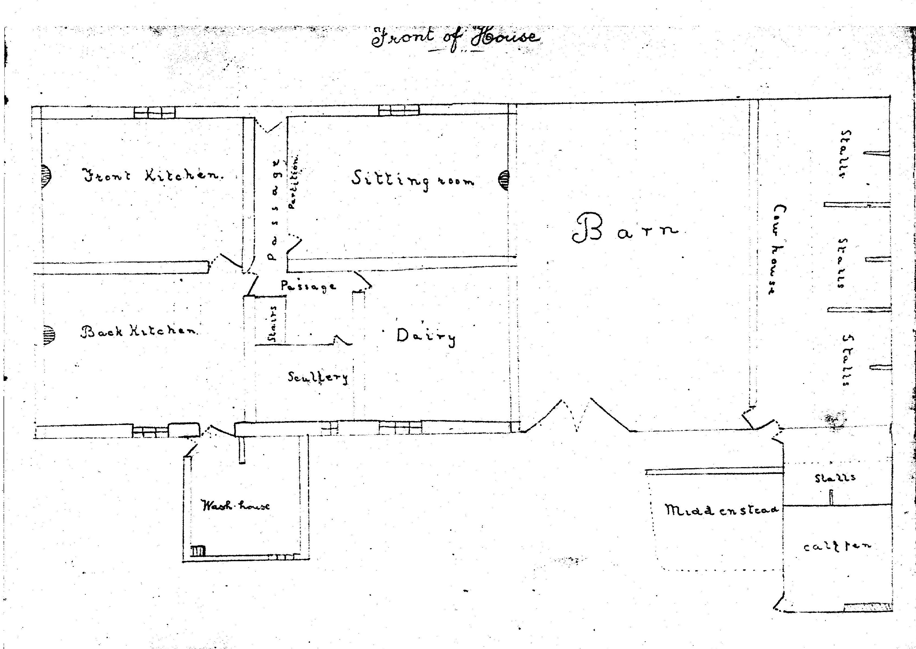
We're lucky to have this plan, drawn in pencil by our father, perhaps at night school, showing the living rooms and farm buildings at Brackenber and what they were used for (He was looking at them from the yard at the back). It was a fair-sized house, two rooms deep, A central door led directly into a passage; a room on each side had a sash window looking onto the road. The room that our father names as “sitting room” and Emily as “best parlour”, contained a piano, horse-hair padded furniture and a big polished table,
Aunt Alice recalled a little desk with two little drawers inside and a lid fastened on with leather and caulker nails; inscribed with an X rounded at the ends, but no date. She also remembered a hall-stand with the date 1689 and initials supposed to belong to J and M Airey. It was made from a wardrobe and had belonged to the last Alice Airey before it came to our grand-father. (This Alice was the 1756 Henry's widow who died in 1842).

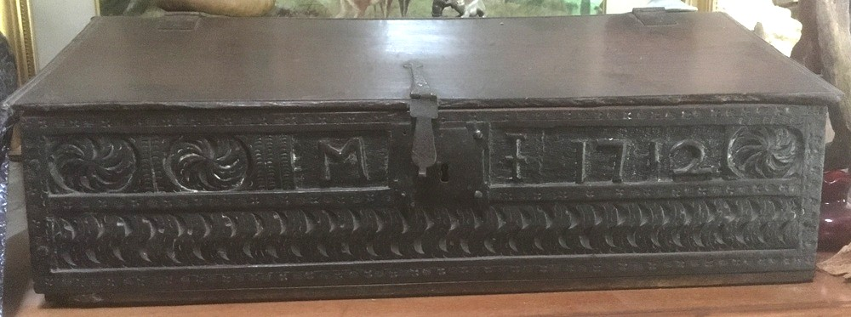
The Bible Box with the initials.

I myself have a Bible box dated 1712 and with initials on it; this was on the hayloft at Brackenber waiting to be thrown out! Grandma told father just before he married, 'It's got Mary's initials on it - she'd better hev it!", (It turns out to be M J)
Emily – remembers the back kitchen as a little room with a warm fire-grate, a table and chairs, and shelves with crockery and, at that time, a pantry under the stairs - perhaps this was an area father didn't investigate! The dairy, she said, was whitewashed and down five steps - sandstone slabs - and had a table in the middle of the floor.
There was a separate room behind each of the three upstairs windows. When Emily and her sister Alice visited, they slept in the bedroom farthest from the barn, Grandma slept on this side of the house, at the back, divided from them by a screen with newspaper pictures, including one of Princess Mary's wedding to Lord Lascelles. Uncle Richard had the room above the front door. This reminded Emily that there was an outside balcony at first floor level, above the best parlour and the front door. Could this be so?
We also learned from a grand 'crack' with Aunt Alice on 30 July 1977 (which ranged from Cromwell to 1900!) that "there was a room above the back kitchen - you had to go up ladder through a window; an old man and woman lived in it, not family -at all", This would go back to the time of a loft for children and servants; before there were staircases; a ladder would be the only access.

ADDING TO BRACKENBER'S ELEVEN ACRES

Aunt Alice thought there were only eleven acres with Brackenber originally. John and I guess these include the three little fields which we find marked "C. Airey" on the 1820 Enclosure map (Shap Fo. 82).

Field acre rood perch
115 0 3 37 (nearest the house we know as Brackenber)
119 1 0 27 (nicknamed Brackenber Gardens or Garden Field)
142 1 2 7 (Ullsmoor Field, off Hulls Moor)

115 is close to the house we know as Brackenber and the other two come up to the road running south of the house. The names above are the ones that Alice used in her account; and they do indicate a holding that's small. We've recently become a bit puzzled, though, because our great-grandfather, born Sept 19 1800, would be under-age in 1820 and the previous Christopher (his grandfather) had died in 1813. Perhaps this later round of Enclosures allowed unusual agreements at local level, and village worthies helping with the dividing up would just know these as Airey fields.
Alice described them as "odds and ends of little fields". Putting her recollections and our Mother's together, we can probably say that the rest of the original eleven acres were fields which were; "just garths from the house to the railway, pig garth, etc."; "the Croft Field" behind the house across the railway; and "the Field House garth, up by Elm Tree", Mother added - in her list, after Croft Field - "t' L field, it went by that name", but none of our maps to date show a field of that shape.
We're not sure whether the original 11 acres would include what Alice named as "the Scalebers (up to the Hassocks), two little fields (meadows) and the tops, ploughed for corn and turnips in rotation; that joined the Waters," (This must be the higher ground east of Brackenber and running south to Waters Farm. Maybe the big 26" map would help us to sort this out?)
To build up the holding, Alice told us, "Father bought in Intacks land etc. and it came to 60 odd acres when we had it," The Intacks provided most of the acreage: they "ran in narrow strips south of Brackenber over the railway: the biggest was Fisher ground, a 30 acre field, also known as braid arse [broad acres]". The Enclosure map marks the Intacks and the two fields owned in 1820 by John H. Fisher. The Fisher land added up to about 24 acres and in the intervening 70 years it might well have been enlarged by the buying of adjacent sections.
Grandfather also "bought Field House land, with a barn, a byre, a shed or loose box and "a little spot just to hold a deeting machine". "And there was the Kern and Quarry field where the Force Beck ran through, down to the road", said Alice. This (117 on the Enclosure Map) was over six acres. So, with more Field House land (acreage at present unknown), we can see grandfather gradually getting towards 60 acres.
Both my Mother and Aunt Alice thought grandfather rented land in Hardendale to Brackenber - another 46 acres. Certainly there are long stretches of great-uncle Richard's fine stone walls between Hardendale Nab (owned by Richard?) and Hardendale village. This suggests they kept sheep up there, but they evidently lived in Shap.
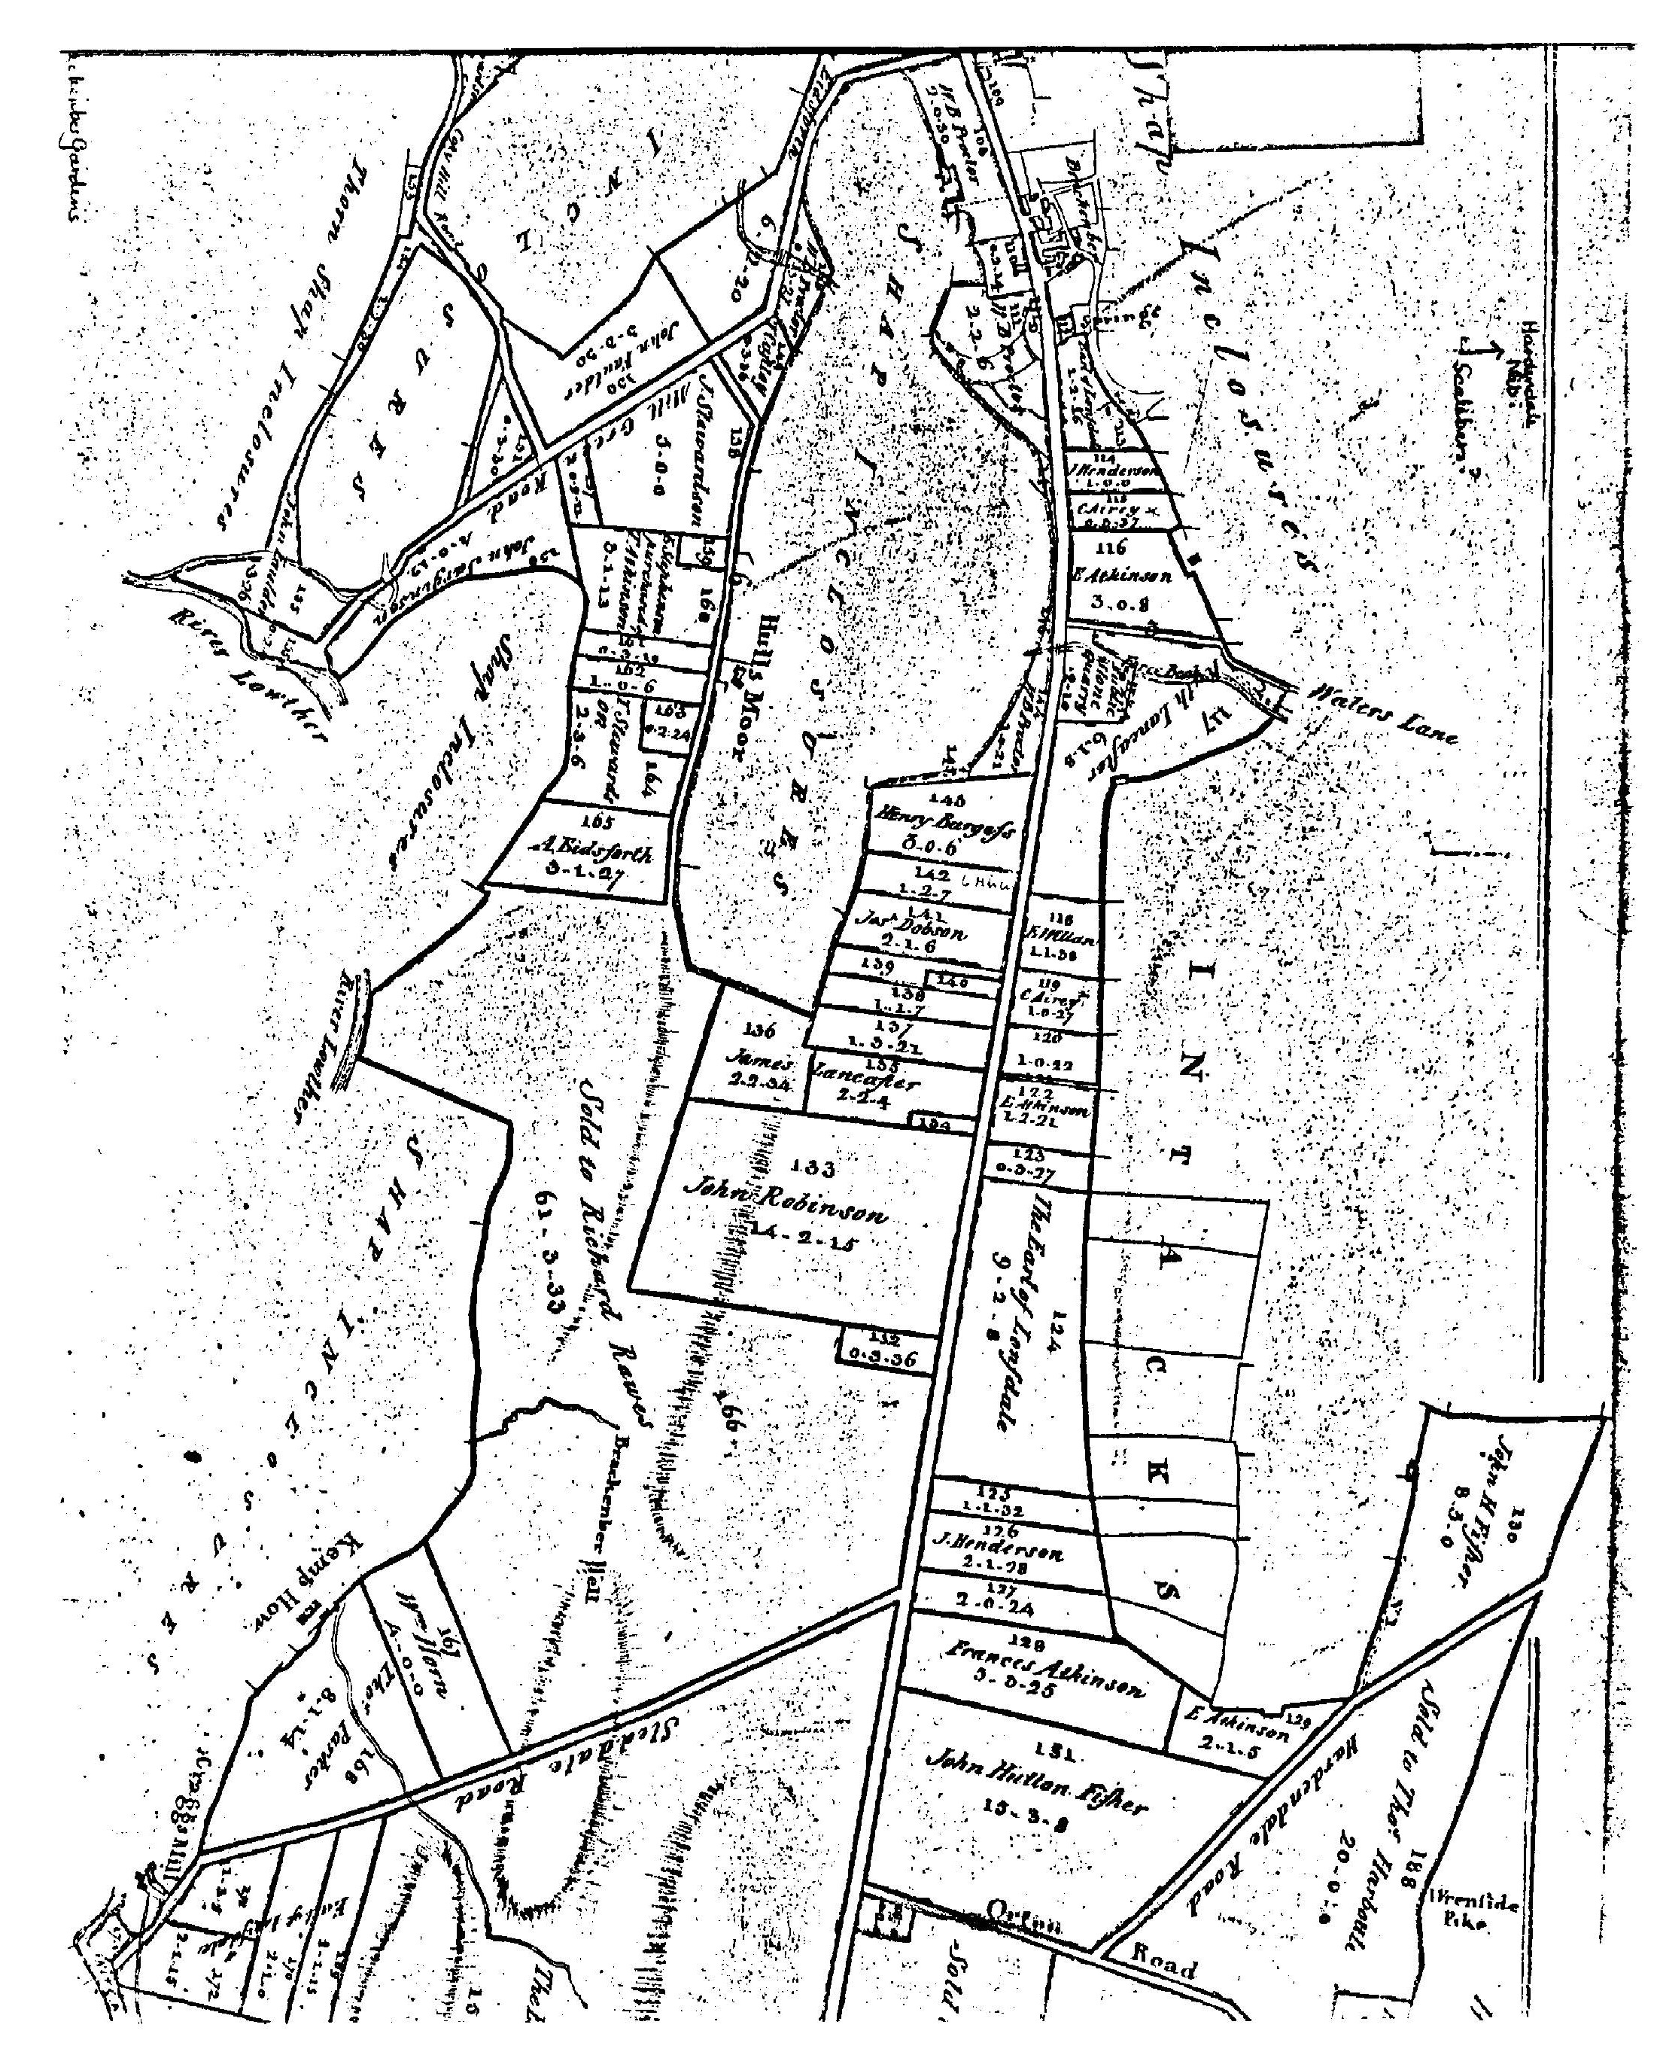

MAKING A LIVING?

Let's take Alice's words again, with the reality of her memories and feelings showing through. She was evidently a great questioner from the beginning and thus had more recollections than most of us from her mother and father's background. Relatives and visitors probably turned over past events with more Interest and precision than we do now and the children of the household listened. I recall my father's detailed memory of seasons and weather and its effects.
Thus Alice could start with what things were like when she was only two:
"When [the Aireys] moved to Brackenber in 1895 there were 17 weeks of winter - father started taking sheep to Manchester and brought a wooden doll back for me,"
Other detail comes from the time when she actually took part in the family's work, first as child under twelve and still going to school:
"We'd have about 30 to 36 head of cattle - t' byre would tie 6 and Fieldhouse about 12 - off and on about 6 to 8 milking - we sold milk, butter and cheese - eight pints in a week for a shilling - we took it on our way to school, and got a ha'penny out of every shilling.
“Someone had to go down street of a Friday to take butter and eggs -workmen got paid that day. An old widow would have 2oz of butter to last her a week, There was a Scotch woman - we'd take her a can of buttermilk on a Monday and she'd take in washing in her own home, and do a day's work on a can of buttermilk. She'd take her clogs and socks off to do the wash - they were too good to wear. Her feet might get frozen, but they'd mend.
“I never milked. Scrubbing, churning and making butter - that was my job. Then dairy classes came to Shap and I got a better idea of how to make it. We had Scotch hands eventually, to work the butter. We used to make 2 or 3 cheeses in the beginning of May, then they were ready for haymaking. You had a mould that would fit - for 1lb., 2lb. One gallon of milk should make a pound of cheese." (Here Mary added: "if ever we. [the Irving family] had any quantity of milk, father used to buy heifer calves and feed them".)
"In 1895 my father used to go from Shap to Rampshow (William Dodd's) and buy about six hogs - grass was better at Shap - and he'd put them in where there'd be a good 'fog' (the fresh grass after hay time). Then he'd go to Roughill (Tommy Dodd's) where he had these green geese. One used to be kept for Christmas: t' others were stuck [a knife in the throat]- we used to catch t' blood - that went into giblet pies.
“Huge pan used to be on in t' back kitchen - these geese used to be thrown in with a hog, salt, pepper - they'd be done by 5 o'clock .... then put into this big cream pot. Mutton fat came up to t' top and sealed it. When it had gone cold, they'd put brown paper over t' tap, tight as you could. Then when you opened it later, it was dinner on washing day, cooked up hot -awful greasy stuff, but some people would have gone through anything for a feed of it in wintertime; from Candlemas on. You could put it into potato hash. One lamb with two geese went into a pot. A steel fork with prongs was kept a' purpose. Six geese for a guinea, Same as hogs."

STATUS & THE SOCIAL ROUND

Grandfather and grandmother Airey did have some compensation. Firstly, they gained status in the village because he had the cash in hand to buy land. They earned respect through Grandfather's role as Churchwarden. He made a donation to the church when it was re-built and evidently got on well with the vicar who, for example, in 1908 sent him a postcard postmarked Exeter: "With kind regards from V. H. Crompton". It was in his two civic capacities, no doubt, that Grandfather wore a long-tailed jacket, with top hat or bowler.
His second role was as member of the Board of Guardians of the big work-house in Shap, "seeing all was in order and that there was no trouble", said Emily. I hope to find out who could became a member of the Board and what the duties were; did they, for example, send people out to work and collect money from them for their keep?
Grandmother Elizabeth earned recognition in her own right. As a devout believer she encouraged church attendance, Emily and her sister Alice used to follow her up the aisle in Shap Church (in the Twenties and Thirties) to the Airey seats (two seats in front of the pews). Grandmother used to look around to see if all the villagers were present. She insisted on the christening of the babies of travelling women who temporarily lodged at the Workhouse, wrapping the babies in her own family's fine shawl.
Thus the pair were able to join the superior social circle surrounding the vicar, being invited to their parties and entertaining them in return. She wore a black silk dress, with some piece of tartan, to Highland dances - a lot of Scots had come down to these parts.

RELAXATIONS - AND EVEN HOLIDAYS

Even Richard joined in some festivities! Emily told us he was an exponent of the clog dance; and had a plaid. We reckon this was for joining in the Scottish festivities that seem to have gone on. And perhaps these were the occasions when "he had one glass of whisky now and then".
Aunt Alice expanded on this too, on one of her visits to Isel in the 1970s:
"He was a great dancer - danced with one partner, and never took her home in his life. Of course he was very magnanimous you know - would bow her down. Square eights and quadrilles, a polka (very modern), long eights ... clog dance - on a board ... sailor's hornpipe - to do it properly they had an oak board about eighteen inches wide. Fancy steps in a corner before they came to their partners - like practising. They'd nod their head and these bits of fancy steps started before they got hold of their partner at all. Fiddle to dance with, and then it got to be a melodion." (Here Mary added: "We had two at Whitestone - George Chapelhow had one and left it when he went to Canada".)
Besides social events, life in Shap on a smaller acreage gave grandfather a lighter workload and the opportunity to take regular holidays for his health. Emily thinks he may have had an ulcer. He used to go regularly to stay on his own at Morecambe at a boarding house (37 Alexandra Road) run by the Ellisons who had lived in Tebay, And to judge by one of his postcards, a fair number of people must have started taking holidays. On Aug 13, 1905 his Picture Postcard home reads "There are 33 of us at Ellisons". We don't suppose many of these were from the farming community; more likely it was time of a Wakes Week in Lancashire towns.
In Sept 1907 he had a weekend at Lancaster and a card postmarked 10 am, 6 Sept informs Alice he's moved on to Heather Bank, Morecambe. Occasionally he took his older daughter, Alice - "all he couldn't manage was her hair, so he took her to the Irving family at Lancaster to have it done!" Perhaps these were happy days; I like his thought for young Alice.
We notice that in 1905 (when he was able to be away at Morecambe) his older son was not yet eleven, so the work can't have been much more than his brother (now 62) could handle.

GRANDMOTHER IN CHARGE

Emily recalls her as "a very austere woman" and, it would seem, rather stern in her Judgement of others. Emily reports her as saying, "It's easy enough to be good, if you're never tempted. S.A. Ebdell was never tempted." (S.A.E. will be identified later!)
She was also a very competent woman; she used to deliver babies in Shap and in Tebay, catching the 7 o'clock train to get there. Her life must have been well organised to make this possible. In the house, she always had a maid: one was Lizie Ashbridge, the later writer of several Picture Postcards (PPCs) to the family; and Emily remembers one who washed the floor around the chair legs! Elizabeth expected Alice to become the maid, though she had hoped to go to private school in Penrith. (She did get to night classes with Danny Robinson, in general subjects, in the 1910s.)
She also had a washing machine!! It was at least 6 feet long, with a handle to turn to swirl the clothes. It stood in the back kitchen, with a partition to hide it from the passage leading into the house. (Was this a novelty in the village? Certainly it was a huge advance from an old washing method recalled by Emily - the "batting tree" in a field near Crosby against which you slapped the wet clothes! And perhaps it was a helpful addition to the boiler, tubs and "dolly legs".
The week was organised: Monday was wash-day and that day's dinner was was cold mutton from the big cream crock, where it had been sealed down with mutton fat; then dumplings, apple or currant, served with white sauce.

NEVER GOING EMPTY-HANDED

Besides her housekeeping and her help in the community, Grandmother Airey kept in touch with a huge number of family and friends - exchanging numerous PPCs, sending parcels and "never going anywhere empty-handed". Emily and I went through the two large albums she still has at Town Head full of PPCs which Grandmother sent and received. These give some idea of the importance she attached to this side of her life and how busy she could be. The run of cards to and from all sorts of people in many parts of England, and even beyond, continues for 30 years, so I can only quote from a few!
Brother Jack (Ullock) sends thanks in 1903 for a parcel; and again on 8 Apr 1904, plus the request to "let me know when you are ready for the eggs for sitting". On 11 March 1904 brother Harry and Belle (York) thank her for a parcel; on 26 November 1906 Annie Wilson (Lanes) writes "the chicken was lovely", and Sarah Ebdell thanks her for a collar, adding "Sorry Kitty is not so well" and "a more open harvest".

In 1905 the collection includes PPCs from:

- Clara and Laura Marshall, cousins in America.
- Cousin Aggie Hodgson, working at Annan.
- Cousin Elizabeth Noble, wife of the stationmaster at Ingleton.
- Ellisons of Morecambe ("pleased to have Chris for the weekend").
- Brother Joseph (Kendal), with thanks for P.O. and stamps.
In 1923 Elizabeth was living as a widow at 4 Woodville, Shap, sending cards to her daughter Alice at Reagill. By 1928 we know she had moved up the road to Brackenber, since a parcel was posted from there to Reagill on November 23. In due course, goods and messages went to grandchildren too! She wrote to her grand-daughter Alice Mawson, by post from Brackenber to Town Head Farm, Reagill, "Please send me the size of your stocking. I will try to get your stockings done when I am away, best wishes your Grandma."
In the 1920s Elizabeth (more modern than the men in the family) used to hire a car to take her daughter Alice and grand-daughters Emily and Alice to Great Asby to visit Mrs. Sarah Ebdell who had a baby linen shop. Sarah later left Elizabeth £200 and her house, "The Hollies". Elizabeth didn't want to go there to live, so she sold the house for another £200. (Emily notes that Sarah was a Baptist and that there was a chapel at Great Asby with baptism down steps in water. This is the Sarah who was never visited by any temptation and whose goodness was therefore not proven!)

A TEMPERATE PAIR ..... A DECENT PERSON

Grandfather Christopher lived to be 75. He died on 22 February 1919 of flu. The family story is that he caught it from his younger son Henry who returned with it from the army of occupation, but there was a world epidemic. Grandmother Elizabeth recovered from her attack and lived for another thirty busy years. She died at Elm Tree, Shap, on 2 February 1949 aged 85.
They were described by their daughter as a "very temperate pair”; and Christopher was described by Alice's husband, Aaron Mawson, as "a very decent man".
This grandfather died five years before I was born, so I never knew him; and I hardly knew this grandmother. Bill and I were born at Brackenber, in Grandma^s house, but in 1926 my parents left to farm in Isel parish. I just remember a train journey to Shap with Bill and Barbara to see her, when we were able to go on our own. The move was part of the break-up of the Shap Aireys and, sadly, was not free from bitterness.
The late marriage, the unmodernised farm and the need to help relatives had, inevitably, been leading up to problems for his family, They surfaced on his death. Brackenber had to provide for two generations. There was the widow who would live another twenty years and the bachelor brother Richard. And there were the two sons, reaching marriageable age and needing a farm each, and the two daughters, due a marriage portion.

SEVENTY YEARS ON – 1993

Most of Christopher and Elizabeth's grandchildren have followed other occupations than farming. Two remained on the land: Alice's younger daughter, Alice, married George Kindleyside and they farmed on Wickerslack; my brother Bill married a farmer's daughter and became a very successful farmer through his unusual scientific knowledge which enabled him to take advantage of new developments and to cope with rapidly changing markets. But it was an almost superhuman effort for him and Martha.
Now there is one Airey farming, Bill's older son, Tom, who is a grand judge of stock and a successful dealer (so far as Government policies permit these days), following in the footsteps of his great-grandfather Airey and his great-uncle Arthur Graham on the other side of the family. Bill's younger son, Alan, has a foot in two worlds: his skills in hedging, fencing and dry-stone-walling give him plenty of work both for the farming community and for the "comers-in".

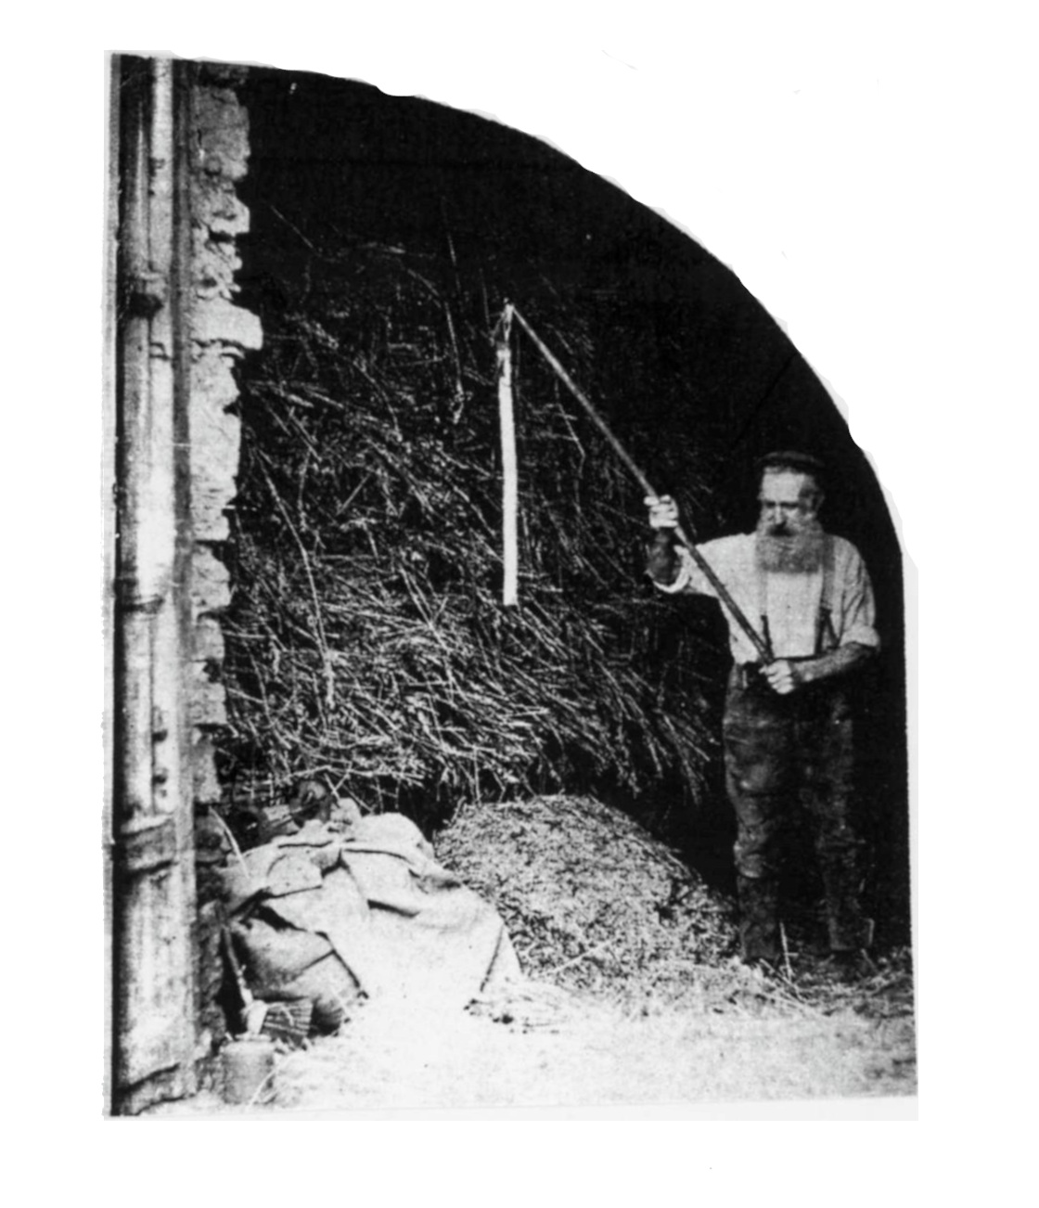
Grandfather Christopher

